**Canadian language attitudes from “coast to coast to coast”: on the pluricentricity of English in North America**

Stefan Dollinger & Lars Hinrichs

# 1 Introduction

Sociolinguists are not immune to wider social developments. One can argue, for instance, that the era of the free trade negotiations of the 1980s and early 1990s[1] are reflected in sociolinguistic theories at the time. While the first generation of Canadian linguists tended to emphasize differences (e.g. Avis et al. 1967, Scargill 1974), the linguistics of Canadian English has seen a subtle but steady influence to that effect as of the early 1980s. The early period was marked by bold statements as to the weakness of Canada-US border as a linguistic divide (e.g. Warkentyne & Brett 1981: 307; Chambers 1980: xxx, Warkentyne 1983: xxx), or even to its irrelevance (e.g. Woods 1993: xxx). The latter point has been occasionally echoed in more recent writings (e.g. Sadlier-Brown 2012: 547).

What generally unites these claims, however, is the lack of a comparative US sample in addition to the Canadian sample, which means that US usage is inferred from indirect evidence only (e.g. dictionary and usage guides, general impressions) but not data collected in the same way as on the Canadian side. If a more appropriate design is brought forth to study cross-border linguistic influences, however, it is almost always shown that the veracity of the Canada-US border and its linguistic effects – subtle yet consistent – can be clearly shown (e.g. Chambers 1994, 2000; Boberg 2000, Boberg 2005, Boberg 2008; Dollinger 2012).

In the context of pluricentric languages, it is noteworthy that “contiguous varieties”, e.g. varieties that border on other varieties such as Canadian and American English, Austrian German and German German and Netherlandic and Belgian Dutch, have traditionally been faced with disciplinary scepticism (e.g. Koppensteiner & Lenz 2020, Scherr & Ziegler 2023). In this context, “non-contiguous varieties”, i.e. those separated by a sea border such as Australian and New Zealand English, or Irish English and English English, have been recognized more easily. Such questions of dominance (heteronomy) or non-dominance (autonomy) are part and parcel of the sociolinguistic theory of linguistic pluricentricity. The present paper sees itself as a contribution to this large and growing oeuvre (e.g. Clyne 1984, 1995, Ammon et al. 2004, Muhr 2012, Dollinger 2019).

Based on a language attitudinal questionnaire, the present paper explores notions of the “standard” for Canadian English and notions of linguistic autonomy as central tenets of pluricentric theory. It is structured in the following way: it will first introduce the constraints of the present data set, collected in the fall (Nov-Dec) of 2023. It will then present the main results, correlations and modelling effects for the 3000-respondent-survey. In a next step, the findings will be put into the context of existing literature on language attitudes and perceptions and Canadian English, before the findings will be interpreted in the larger framework of the sociolinguistic theory of pluricentricity, which is occasionally critiqued as nationalistic (e.g. Schneider 2022) or more widely misunderstood (e.g. Elspaß 2025, Herrgen 2015). It will be highlighted that pluricentricity has been the dominant approach in the sociolinguistics of World Englishes and that other concepts, purported to stand in competition or to “complement” pluricentricity, appear in philological frames that face decolonial and dehegemonic challenges. Where conducive, data from other languages, e.g. Austrian German, Belgian Dutch, or Catalan will be brought in to recognize the special role of what since Clyne/Muhr are often referred to as “non-dominant” varieties.

# 2 Literature

Following pluricentric theory (Leitner 1992), two English varieties can be considered dominant today: Standard English English and Standard American English. All other varieties, including Standard Canadian English, are non-dominant varieties (e.g. Clyne 1992, originally called “dominant” and “other” varieties”) and are confronted with phenomena such as linguistic insecurity (Preston 2013). It is one purpose of this study to assess the belief of Canadians in the linguistic autonomy of their own standard, Standard Canadian English. Few studies have hitherto investigated the phenomenon of linguistic attitudes and have either focussed on impressionistic assessment or focussed on the linguistic insecurity among Canadian English speakers.

The attitudinal literature on Canadian English is limited to date. Chambers (1986) assesses that Canadians, due to variation in spelling, are not favourable towards linguistic standards, while Owens and Baker (1984: 349) suggest that, in the early 1980s, Canadian English was Americanizing, though 1 in 4 Winnipeggers still considered the British form as “correct”.

**The 1977 UVic student study**

Previous attitudinal work sough to correlate measurements of attitudes towards country and statehood with linguistic features. Warkentyne (1983) and Gulden (1979) seem to report on the same study, conduced in 1977 at the University of Victoria undergraduate in linguistics cohort. Gulden (1979: 45) reports of 64 students, while Warkentyne (1983: 72) speaks of “68 Canadian-born in two introductory English linguistics courses”, and “most of them indicated” to be “preparing for a career as teachers of English” (Gulden 1979: 45). Their results, however, are identical, deriving from one an the same study.

The study assessed on the one hand respondents’ general attitudes towards Canada, the US and the UK and on the other it was measuring more specifically Canadian national identity with three questions:

[a] questions about an obligation to buy Canadian products,

[b] an evaluation of Canadian-produced TV programmes,

[c] and a direct question about the existence of a Canadian national identity

(Gulden 1979: 57)

The study assessed attitudes on a scale from -1 (negative) to +1 (positive). General national identity was assessed at +0.292, so slightly positive in this student cohort of a median age of 23 in 1977, while the for the linguistic items the score was lower +0.193, suggesting that “This group of Canadians does not feel very strongly about speaking a distinctive variety of English called Canadian English” (Gulden 1979: 58, Warkentyne 1983: 73, Table 1). The linguistic assessment was based on the following questions:

1. Is the language of CBC announcers the standard for spoken Canadian English?
2. Should a Canadian be offended if people from other countries consider him to be an American?
3. How should he feel if taken for British?
4. Does it make sense at all to speak of Canadian English as different from American and British English?

With the answer options in six steps from -1 (negative) to +1 (positive). Some of these question appear somewhat loaded (“does it make sense at all”, a distinction between US “offended” and UK “how should he feel”) and were replaced in the present study with there-extrapositions or Yes/No questions on Likert scales.

Canadian national identity was slightly positive among these young future English teachers, with Canadian linguistic identity somewhat lower. The overall mean in terms of national identity was +0.252 (Gulden 1979: 58). Interesting in this context is the finding that the questions “asking about Canadian identity directly show the most positive answers” (ibid: 58), which would related to questions [c] and [g] above. For question c the value is +0.563, the the linguistic identity, [g] only +0.344. It is possible that the rather negative framing of [g] underreported linguistic identity assessments, leading Gulden to summarize that “Canadians, or at least the present group, seem to believe in their national and linguistic identity, possibly more so than the low value of the entire [compound] variable would suggest” (ibid: 58) and lists as possible causes “an unfortunate choice of questions an/or by intervening factors such as modesty or insecurity” (ibid: 109). We have learned since that the factor of linguistic insecurity needs to be mitigated against not only in non-standard settings but also in non-dominant standard variety settings, such as Canadian English.

The study’s general national identity results, however, do not always fare positively for Canadian-ness. As Table 1 shows, the teacher’s degree students rated the U.S. “higher as a country in general” over Canada (ibid: 115), and, more strongly so, the U.K. over Canada, at that same higher level the U.K over the US:

|  |  |
| --- | --- |
| 1. Preference ratings |  |
| US (-1) vs. Canada (+1) | -0.219 |
| UK (-1) vs. Canada (+1) | -0.382 |
| UK (-1) vs. US (+1) | -0.395 |
| UK (-1) vs. US (+1) benefits | -0.307 |
| 1. Canadian national identity | +0.292 |
| Canadian linguistic identity | +0.193 |
| 1. Personality ratings |  |
| Americans | +0.219 |
| British | +0.222 |
| Canadians | +0.205 |

Table 1: Attitudinal ratings in 1977, UVic students (Warkentyne 1983: Table 1)

The fourth line in the preference ratings refers to impression of the perceived benefits that an association with the UK or the US offers to Canada. In 1977, this sample was clearly on the UK side as beneficial. More generally, British people were rated more positively than Canadian people, but the Americans the lowest. Warkentyne comments that the “low scores on the items concerning Canadian identity should allay any fears that nationalism may be carried to the extreme” in that sample (1983: 73). Discussion the correlations among the variables, including those about self-ratings and satisfaction in general, Gulden concludes “a striking combination”: “those who do not have a very high opinion of themselves or any other people (except Americans) are more likely to favour the U.S. over the U.K.” and those who show a high self-evaluation “are correlated with a preference for the U.K. over the U.S.” (ibid: 123-4).

**The 2000s: an increase of Canadian linguistic awareness**

A generation later, studies that use direct questions to assess respondents’ attitudes towards linguistic autonomy and found that they had markedly improved, with considerable majorities offering affirmative responses to the following questions. A 2009 Vancouver study found that:

* 81% believed that “there is a Canadian way of speaking English”
* 73% claimed to be able to “tell Canadian English speakers from American English speakers”
* 69% considered “Canadian English are part of [their] Canadian identity”
* 74% wanted Canadian English “taught in schools, using Canadian dictionaries, grammars etc.” (2009 data, Dollinger 2020: Table 4.5)

McKinnie & Dailey-O’Cain (2002) polled Ontarians’ and Albertans’ assessments of “pleasantness” and “correctness” of varieties of Canadian English. In terms of “correctness”, both Albertans and Ontarians consider BC English as most correct (ibid: 283). A paper on 6-12 year old elementary students and their parents in BC and Alberta found that 69% considered the Standard Canadian English speaker as “sounding Canadian”, while the Mandarin and Cantonese-accented speaker scored 26 and 23% Dollinger, Chan, Pasula & Maag 2024: 326), which is attributed to “a bias towards a StCanE accent which we attribute to the forcefulness of standard language ideology in Canada” (ibid). It was also shown that “the multilingual speaker is less tolerant towards L2-accented English than monolingual speakers” (ibid: 329).

What is available to date for assessments of Standard Canadian English are province-related findings from Manitoba, Alberta, Ontario and BC, but not more comprehensive studies. The present study aims to fill this void on a national scale to a degree, as it includes data from all provinces and territories and is meant to gauge to what degree “Canadian English has become a reality for many of its speakers” (Dollinger 2019: 224).

# 3 The data

|  |  |  |
| --- | --- | --- |
| **Province/Territory** | **Live now (n)** | **Formative years (n)** |
| BC | 639 | 451 |
| AB | 666 | 509 |
| SK | 277 | 284 |
| MB | 328 | 298 |
| ON | 455 | 502 |
| QC | 123 | 104 |
| NB | 47 | 43 |
| NS | 46 | 46 |
| PE | 62 | 50 |
| NL | 41 | 45 |
| YT | 16 | 5 |
| NT | 18 | 1 |
| NU | 1 | 0 |
|  | 3034 | 2719 |

The questions

# 4 Results & Discussion

**Attitudinal autonomy in CanE**

Figure 1 offers an first glimpse at six key questions among Canadian residents (this includes transient residents, e.g. foreign students). Taken the answers of “Definitely yes” and “Probably yes” together, a “Canadian way of speaking” is confirmed by 70.1%, with 9% undecided. Compared with 81.1% from 2009 from a six-point scale, the five point scale probably more closely reflects the present state. Similar percentages, 68% or more than two thirds, see CanE as a “distinct kind of English” like American or British English. On the question of spelling, the sample is more divided, with more undecided ones (26.4%) than definite yeses (24.8%). This is somewhat add odd with almost 39% “definitely” confirming that Canadian universities should encourage Canadian spelling and a clear 78% wish to have a Canadian spelling option in software applications, with 12% undecided. Lastly, in terms of a free digital dictionary of CanE, nearly 71% would use it.

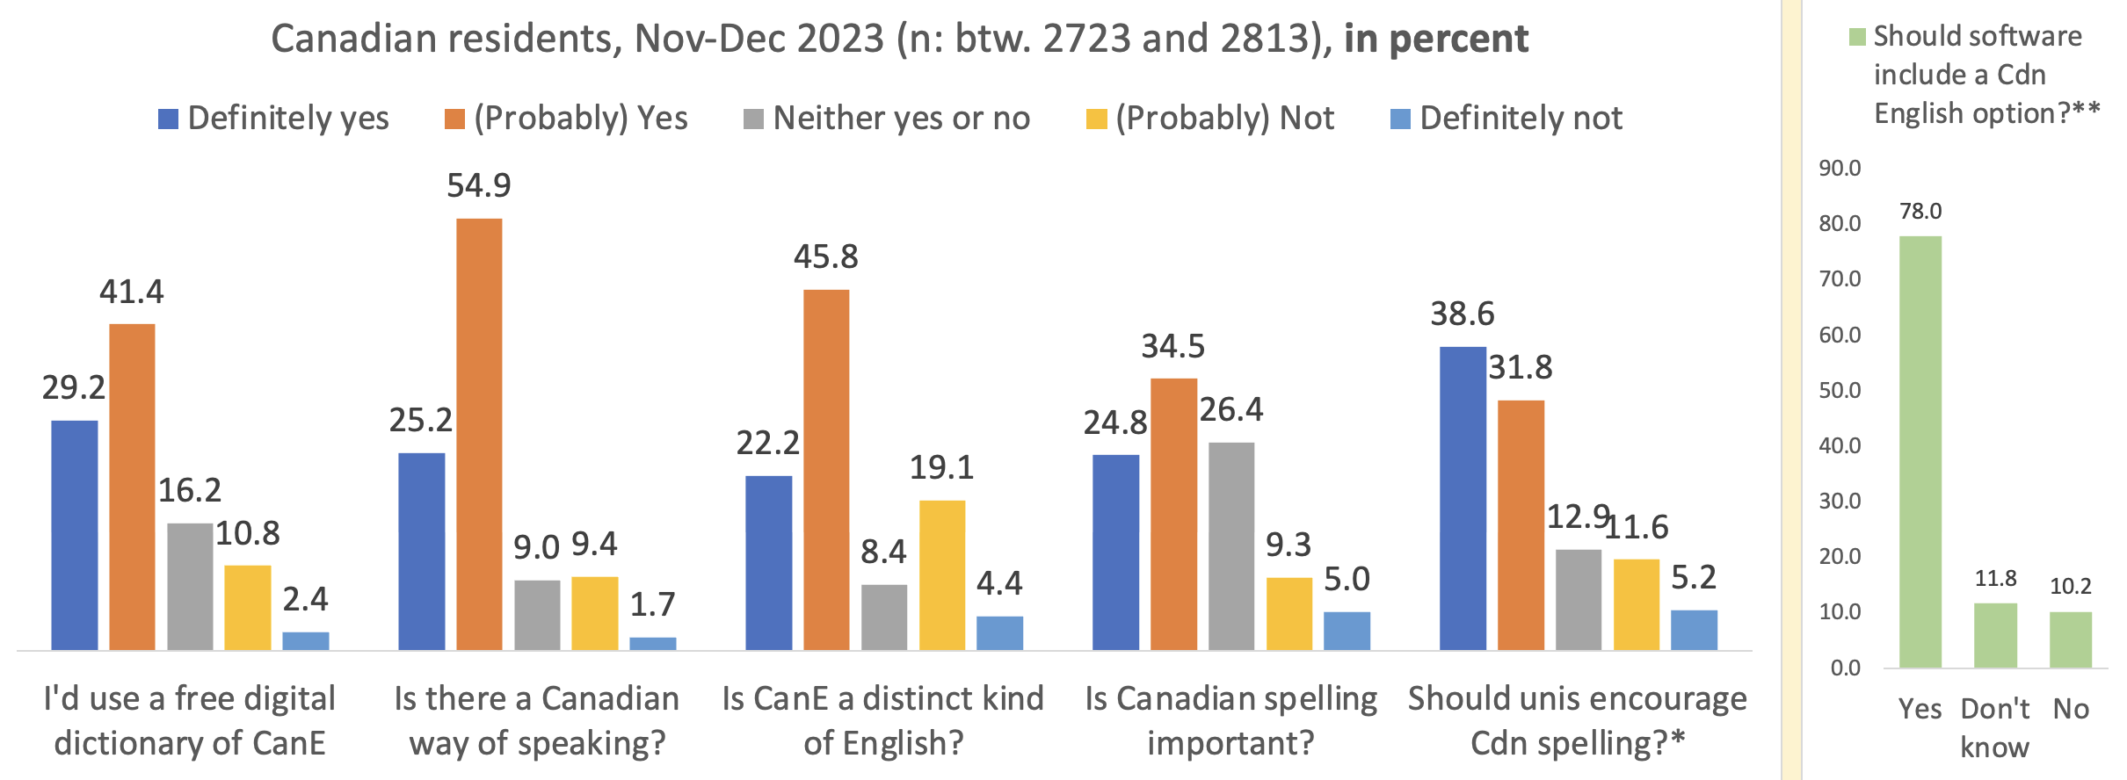

Fig. 1: Majorities confirm questions on the linguistic autonomy of CanE among the Canadian residents.

With such answers the linguistic autonomy of Standard Canadian English seems well enshrined at this point, confirming the 2009 data overall and showing considerable differentiation from the early 1980s, when “Americanization” was the most virulent attribute of Canadian English. This change in attitudinal outlook is remarkable and warrants a closer look at the social distribution of those who recognize Canadian English – most commonly through its standard that was documented and codified by 1967 (Gregg 1993, Dollinger 2019: xxx) – as a distinct variety of English.

**Familiarity with “Standard Canadian English”**

Standard Canadian English is a concept that has been in in academic circles use since the 1960s. It is, as predicted by pluricentric theory, a key concept whose understanding is a sine-qua-non for an appreciation of the linguistic autonomy of Canadian English. In the public and in schooling, however, uptake of SCanE as a term has been much slower. While in the public, the perception of a “Canadian English” has been much stronger, even that discourse is subject to fluctuation. Figure a shows some data to that effect, which correlates the use of Canadian dictionary titles in the Canadian since the 1970s with the term “Canadian English”.

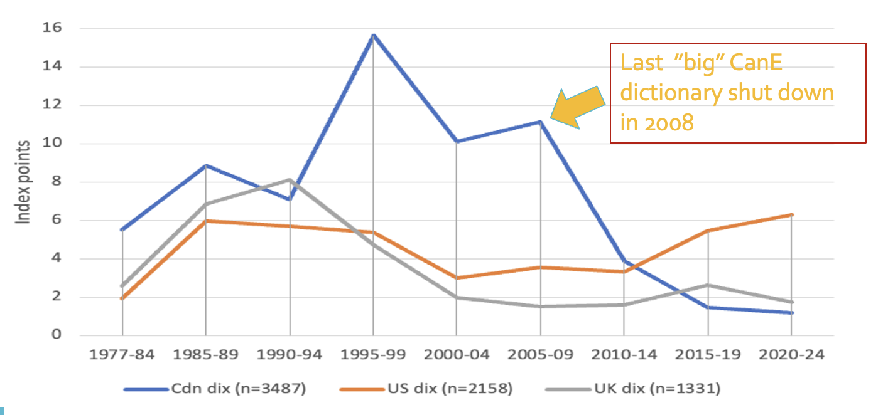

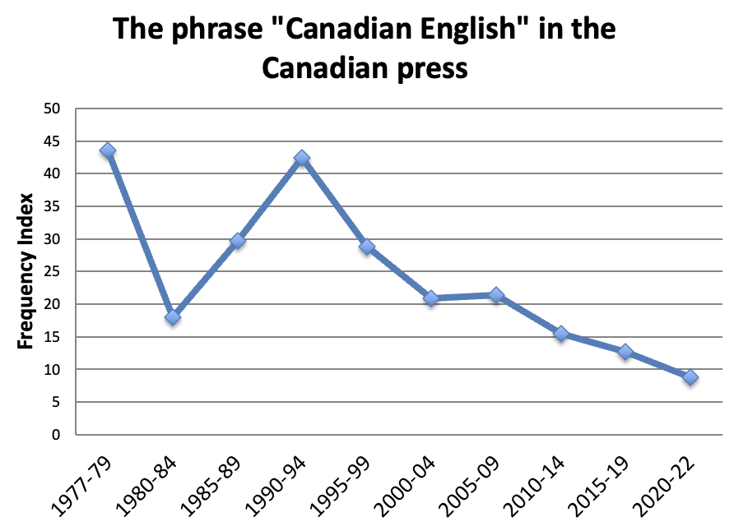

Figure a: Canadian dictionary titles and the phrase “Canadian English” in the Canadian press

It can be see that in these normalized comparisons since the year 1999/2000 both Canadian dictionary names and the term “Canadian English” have been declining, with the dictionaries trailing by a period of five years.

Figure b summarizes the recognition of the term “Standard Canadian English” or “Canadian Standard English” by region. xxx explain Figure b.

Ontario: most positive  
NL: less positive  
PEI: like BC  
Territories: most negative

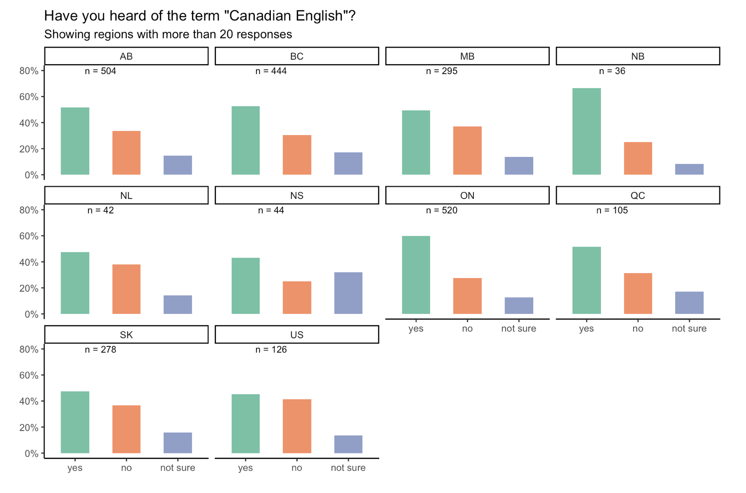

Fig. b: Add PE: 44 in Formative period

The assumption is that if speakers are familiar with Standard Canadian English they will be more likely to comprehend the social relevance of the variety as a marker of identity. Such awareness would therefore be strongest in Ontario, New Brunswick, BC, PEI and Alberta, yet lowest in Newfoundland and Labrador, Nova Scotia and the Territories.

Figure d shows the correlation of the question with the status of multilingualism. Monolingual speakers, socialized in Canada, are significantly less likely to “have heard” of “Standard Canadian English” or “Canadian Standard English”. Monolinguals have by contrast a “default” of “English unspecified” as a variety and need to learn to appreciate the special characteristics of Standard Canadian English.

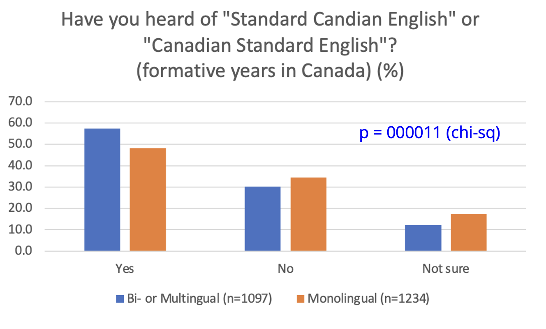

Figure d: Heard of StCanE and Yes/No Monolingual

Figure d shows that Multilinguals who have been raised in Canada are significantly more likely to have heard about Standard CanE. What, however, do they understand by the term, which is used in specialist circles, but not, as Figure a, has shown, in public discourse, where unspecified “Canadian English” is the term of choice?

The open answer form solicited definitions of Standard Canadian English, with the options to decline (“don’t know what it is”, “do know it but cannot describe it well”), should yield only the answers of the confident respondents in that aspect, some of which are reproduced below:

|  |  |
| --- | --- |
| Definition of “Standard Canadian English” | Social characteristics |
| “English used across the country” | 15-19, US-raised, female now in Montreal for UG), fluent English & Spanish, French advanced; Ashkenazi |
| “It's a **normalised pronunciation** of English that one would hear in somewhat formal broadcasts from the **CBC**” | early 60s, male, but L2 multilingual, English & French fluent, Italian intermediate, Spanish & Chinese beginner |
| **“standard** phonetic, syntactic, and semantic features associated with **Canadian anglophones”** | 4th year student, Anglophone, French intermediate, Russian beginner |
| “I assume it is the Canadian English **of the dominant group (socially, in number)** and that corresponds to what one would hear in **mainstream media**.” | Montrealer, 50s, female, Francophone + Anglophone (Bilingual in the official sense), intermed. Italian |
|  |  |
|  |  |
|  |  |

It can be said that the attribute of “educated”, normally a mainstay in standard variety definitions (Trudgill xxx) does not feature prominently in the overall sample. Xxx discuss further

One additional question that can be raised from the quantitative data and the comments is that the youngest age cohort is the one least likely to have heard about StCanE. Only 10 of the 116 youngsters aged 15-19-years who were socialized in Canada (162 overall, including newcomers) know what “Standard Canadian English” is, which raises the question how English is taught at Canadian schools, without using a key concept.

**“Canadian way” of speaking**

A less technical way of gauging the awareness of Canadian features in English is to ask about a “Canadian way” of speaking. Without using linguistic terminology of standard varieties, the respondents answer a personal assessment or impression. Fig. 2 shows the results for residents (left) and those who spent their formative years in Canada (right). It can be discerned that the formative dwellers have a considerably higher positive correlation with a “Canadian way of speaking”, while the mere residents are, on average, some 20 percentage points lower.

|  |  |
| --- | --- |
|  |  |
| Fig. 2: By Canadian residents | By formative Region in Canada (Ages 8-18) |

The recognition of this kind of linguistic autonomy of CanE seems to be a female-driven dimension for the most part, as in both charts they are, overall, more likely to answer positive to a Canadian way of speaking. In terms of age, we see a slight decrease among the younger ones, more some among the residents than among the formatives, which to a degree will correlate with education: as we will see below, the more educated one is, the more likely one is to recognize Standard Canadian English.

**Standard Language Attitude Index (SLAI)**

A further attempt to gauge awareness of standard varieties is via a composite Index. Explain SLAI make-up.

Figure c shows an index based on five factors. Education is a highly significant factor. Generally speaking, the higher the education, the more likely people are to recognize Standard Canadian English.

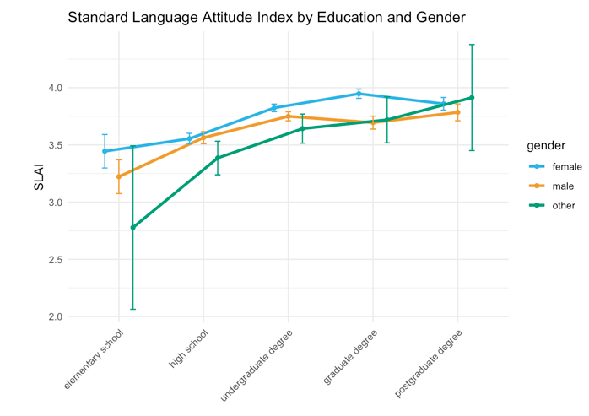

Figure c: SLAI, education and gender

The males are the one group that seem to “stall” from the undergraduate level onwards and not increase their awareness further.

**“Distinct Variety” and Ethnic Orientation Index, Multilingualism**

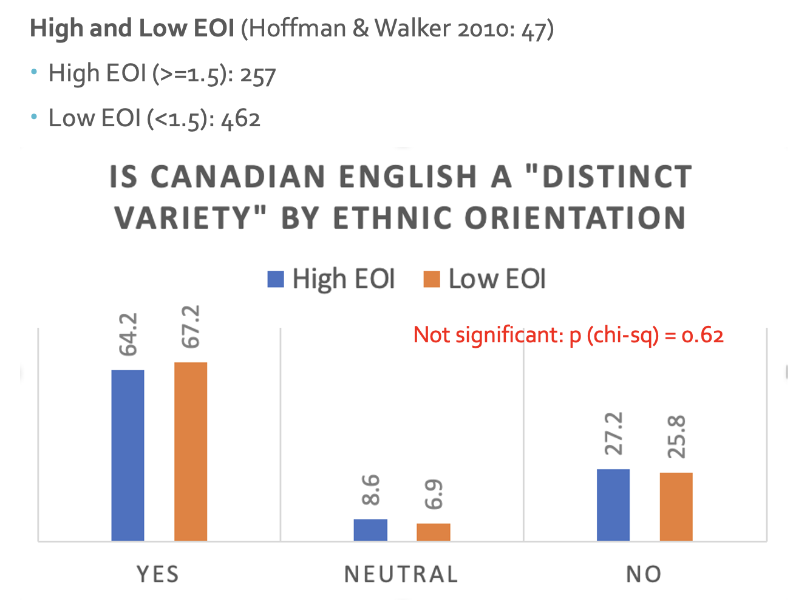

Can we do SAI and EOI and Education like Figure c above?

**The English Language Use Index**

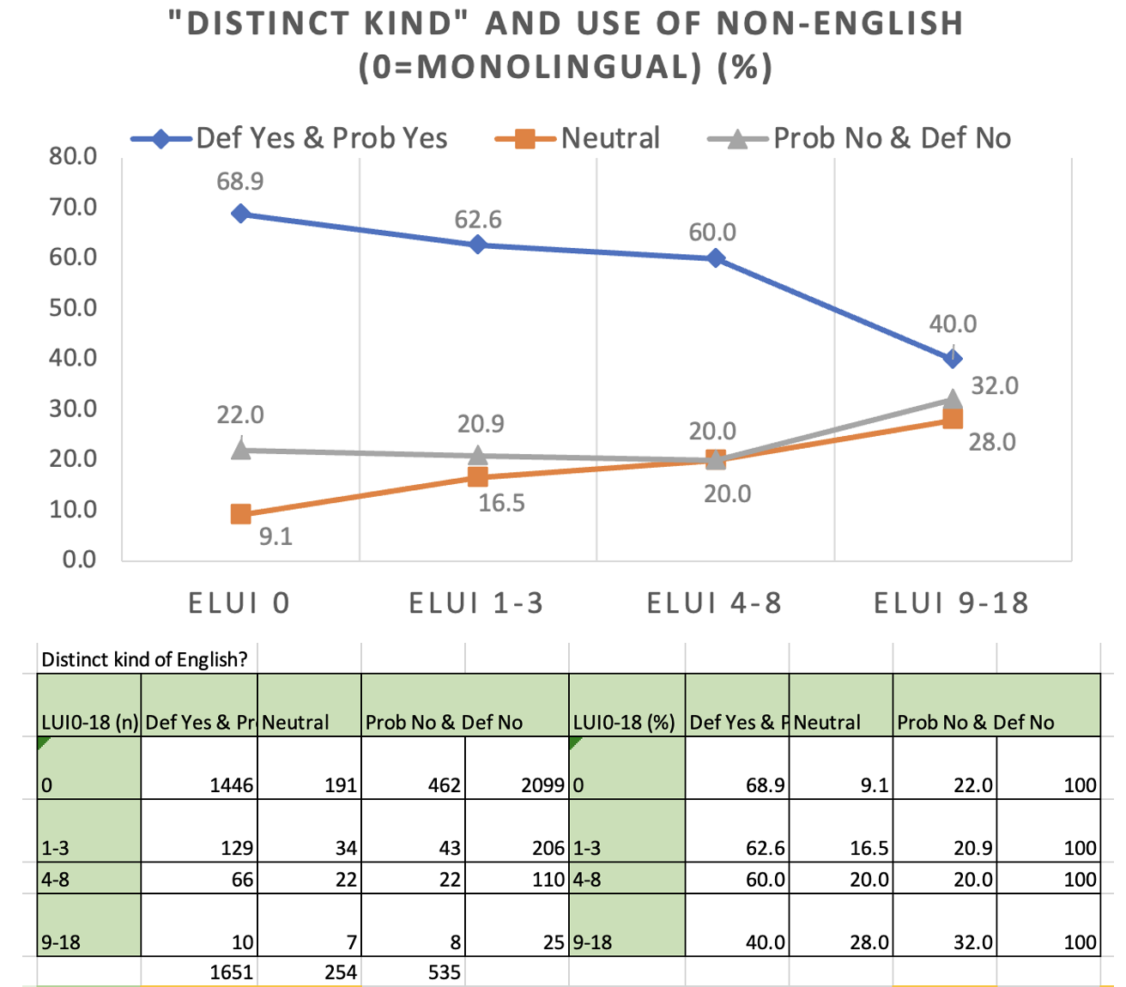

Figure: ELUI in four groups and Formative Years in Canada

The ELUI suggests that the monolinguals (ELUI = 0) are driving the identification with Canadian English as a distinct variety. The higher the ELUI, the less likely one is to conceptualize Canadian English as an autonomous variety, which is consistent with multilingual children and their parents in a study in BC and Alberta (Dollinger et al. 2024). It may seem counter intuitive that those who speak more than one language would be less open towards the autonomy of Standard Canadian English but in the lived experiences – one may have learned American English in the Philippines before coming to Canada or UK English in Hong Kong – the Canadian dimension in English seems to be less important for the multilinguals.

While we know from previous work that local terms “do not register with the bi- and multilinguals to the same degree” as the long-term resident population (Dollinger 2012: 529), this explanation does not apply for the results shown here to the same degree as all spent at least 9 years from ages 0-18 in Canada. While among multilingual newcomers the adoption of Canadian items is an exception (only 1 in 5 local forms was used, in that study the term homo milk ‘whole milk’) (ibid: 529-30), some of their predominant UK forms reinforce Canadian English features that seem to “preserve some of the Canadian markers that local speakers seem to be losing” (ibid: 530).

It that light the result in Figure x is only at first glance surprising. Figure x uses the Standard Language Attitude Index to correlate it with Monolinguals and Multilingual speaker and their genders. It is shown that there is no difference in SALI in both men and non-binaries, yet that women who are multilingual tend to be less positively oriented towards Canadian English.

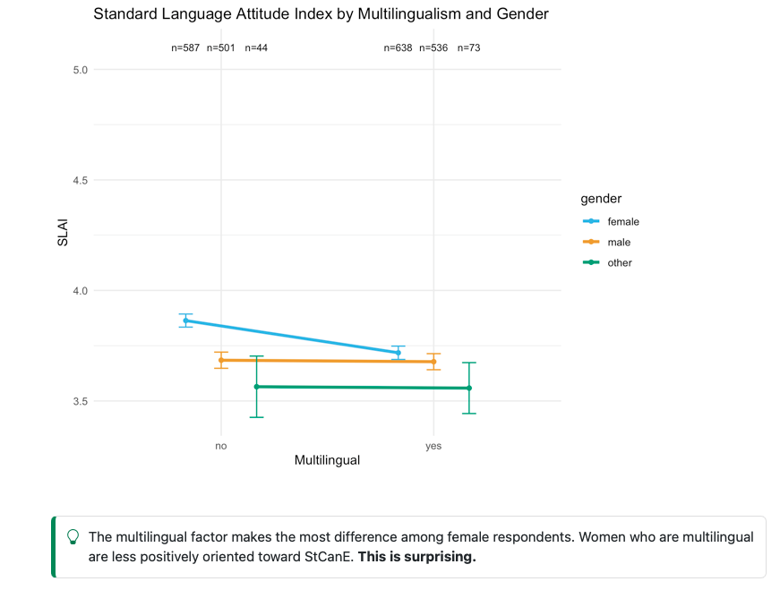

Figure x: SLAI, multilingualism and gender

Question: let’s take out the spelling variables of SLAI and redo Figure x with only these

**Spelling in Canadian English**

The question of spelling is treated different in Canada than in most other countries. It is subject to more inner-Canadian variation that correlates with the country’s independent school boards and being exposed to both British and American, as well as to Canadian pressures.

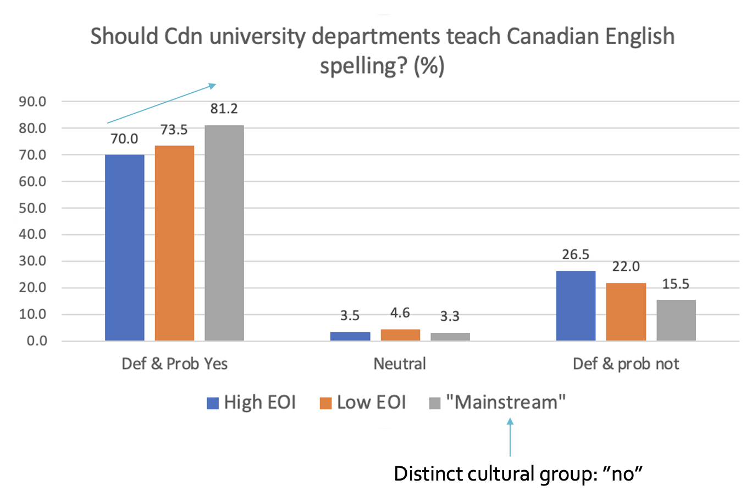

ADD chart on “Spell” – personal assessment whether spelling is important.

# 5 Conclusion

# 6 References

1. Canada-US Trade Agreement in 1988, NAFTA in 1994, the European Union 1993 and the founding of the World Trade Organization in 1995